Which waterfalls will you visit?
- Mill Creek Falls - 1 Mile
- Barr Falls - less than 1/4 mile from Mill Creek Falls
- Pearsony Fall - 1.2 Mile trail 1/4 Mile to falls
- National Creek Falls - .7 Mile
- Lemolo Falls - 3.2 Miles
- Warm Spring Falls - .6 Miles
- Clearwater Falls - 1/4 mile
- Whitehorse Falls - No hike
- Watson Falls - .6 Mile
- Toketee Falls - .8 Mile
- Susan Creek Falls - 1.9 Miles

Why are these kid-friendly?
- All of these hikes are less than five miles round trip making them great for kids.
- Wide open paths with little to no drop offs.
- No rattlesnakes.
- No poison oak.
- Lots of room to run around.

Day Trip 1
- Mill Creek Falls - 1 Mile
- Barr Falls - less than 1/4 mile from Mill Creek Falls
- Pearsony Fall - 1.2 Mile trail 1/4 Mile to falls
- National Creek Falls - .7 Mile

Mill Creek Falls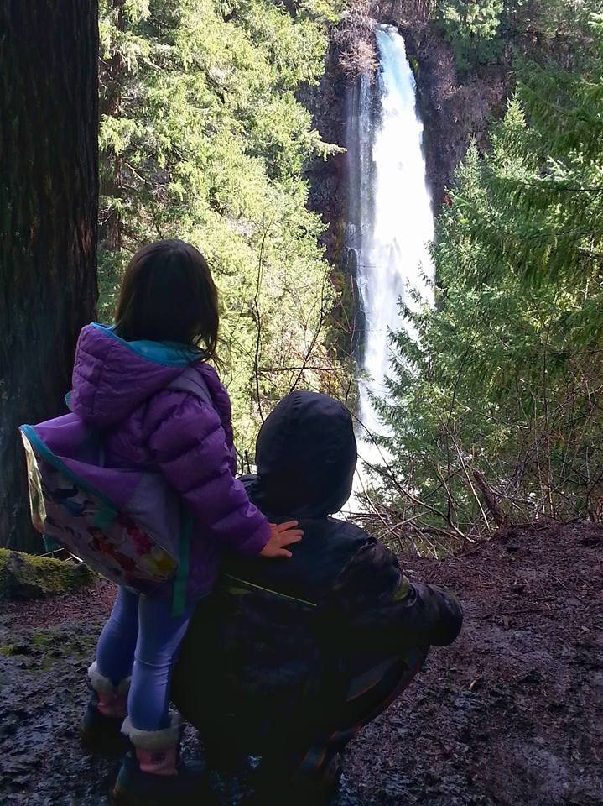

Barr Creek Falls
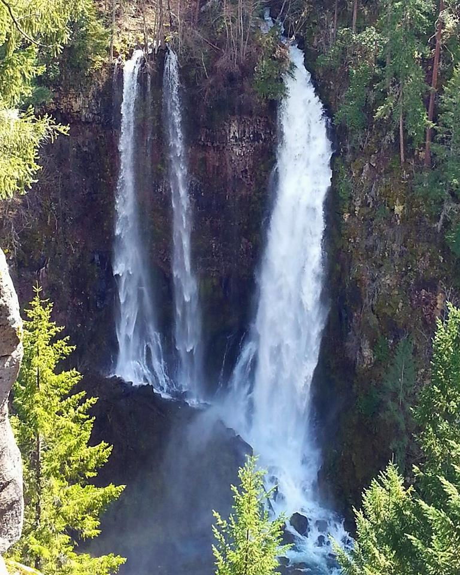

Pearsony Falls
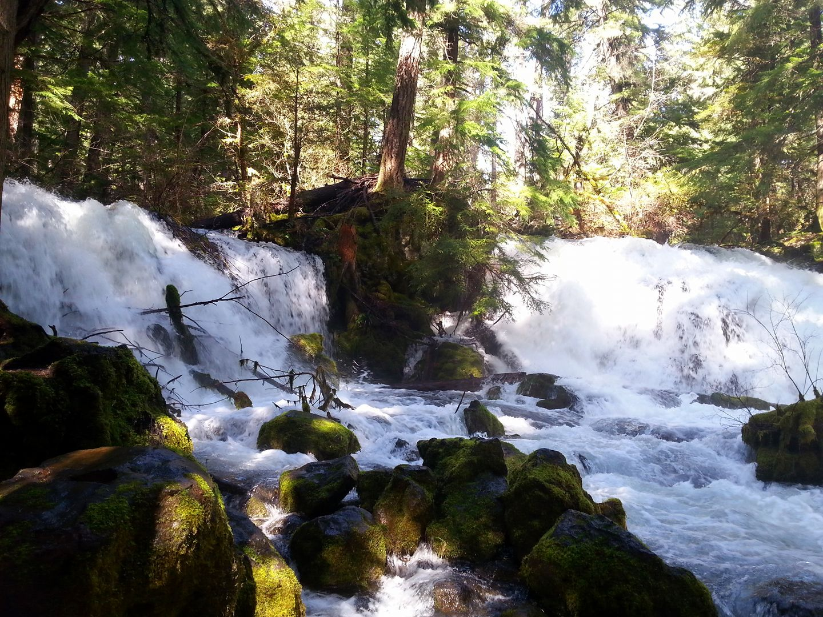

National Creek Falls
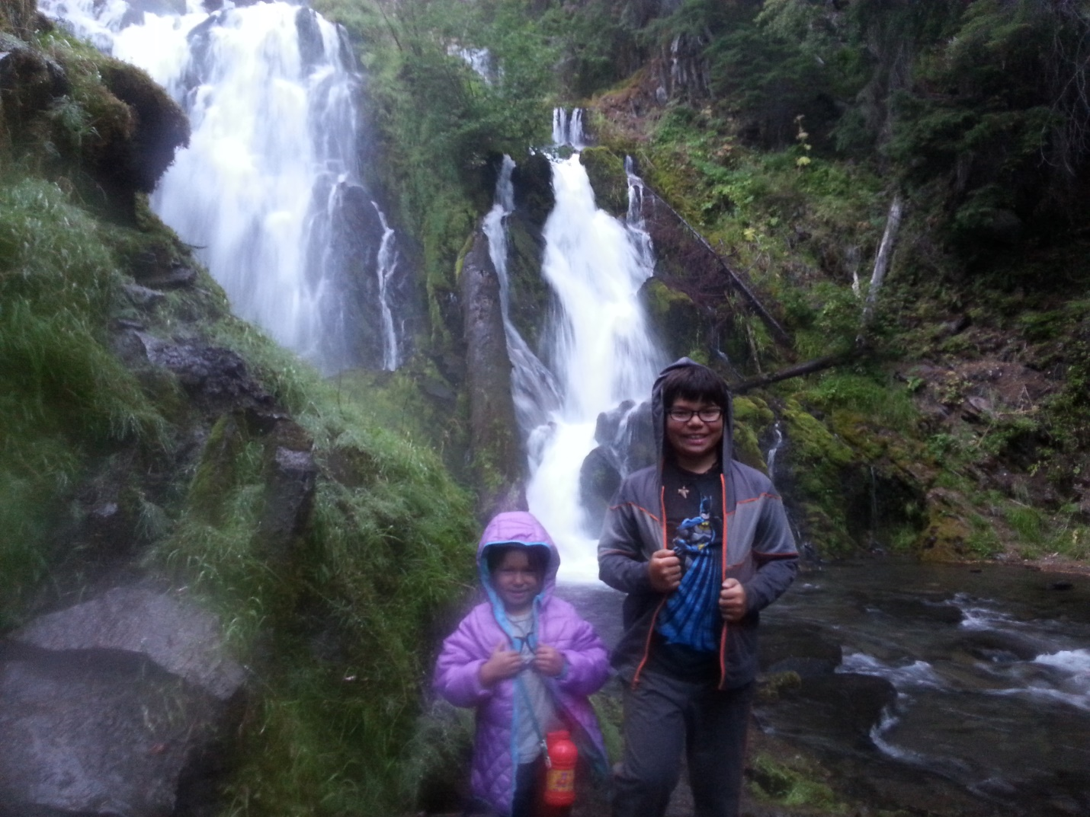

Day Trip 2
- Lemolo Falls - 3.2 Miles
- Warm Spring Falls - .6 Miles
- Clearwater Falls - 1/4 mile
- Whitehorse Falls - No hike

Lemolo Falls
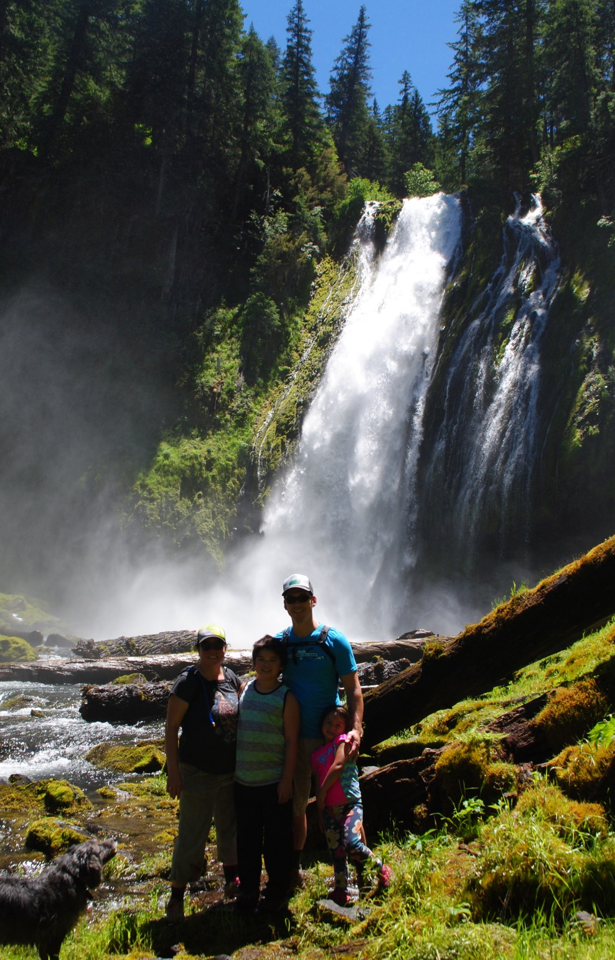

Warm Springs Falls
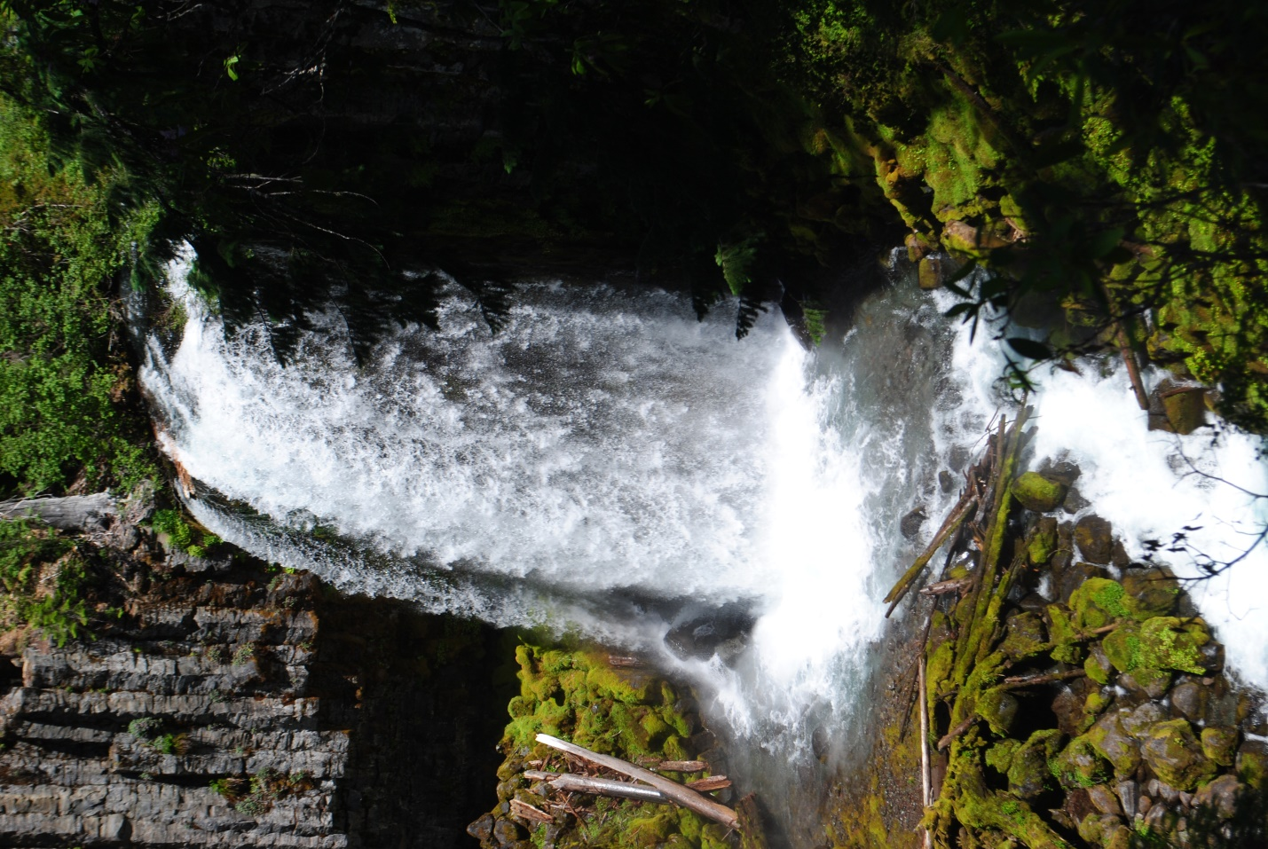

Clearwater Falls
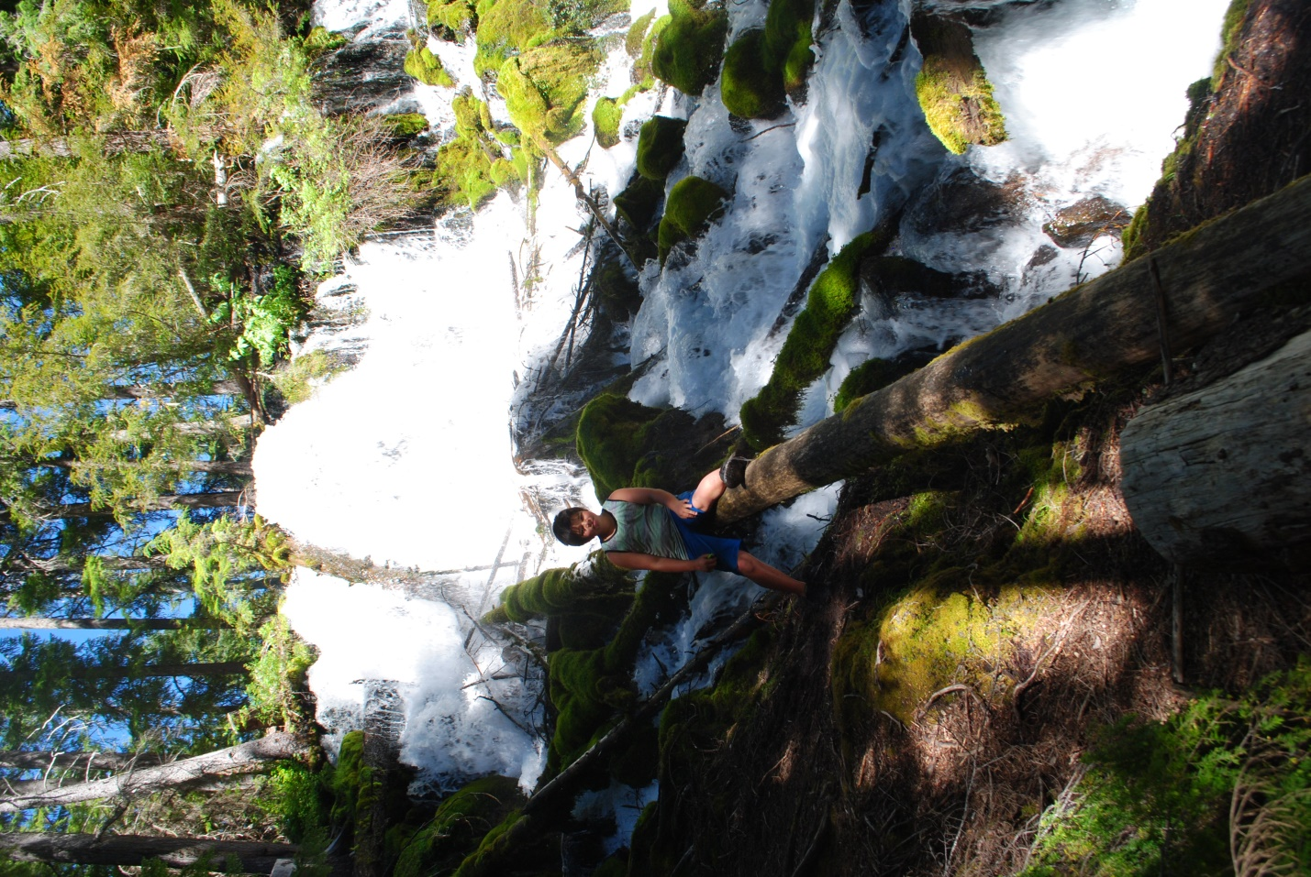

Whitehorse Falls
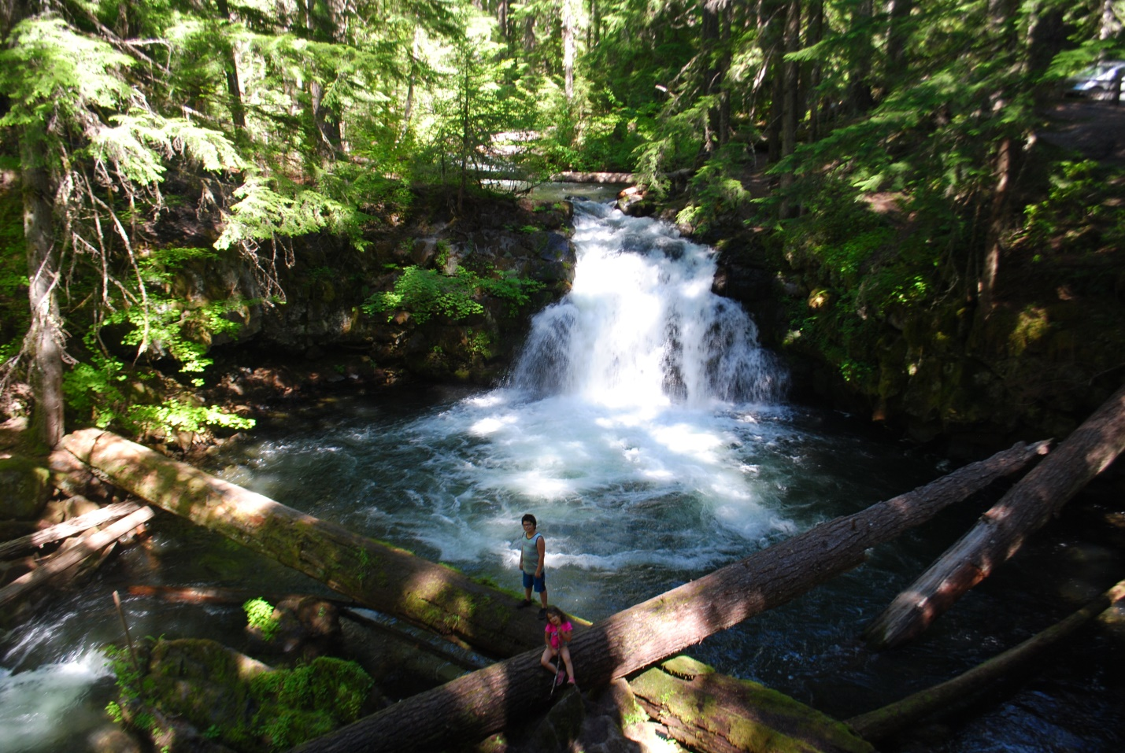

Day Trip 3
- Watson Falls - .6 Mile
- Toketee Falls - .8 Mile
- Susan Creek Falls - 1.9 Miles

Watson Falls
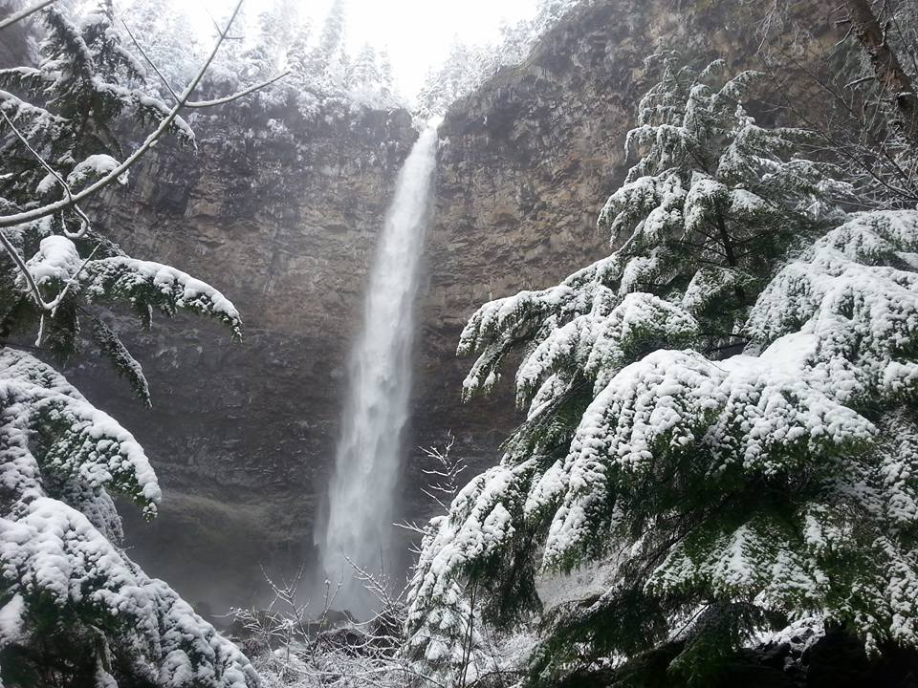

Toketee Falls
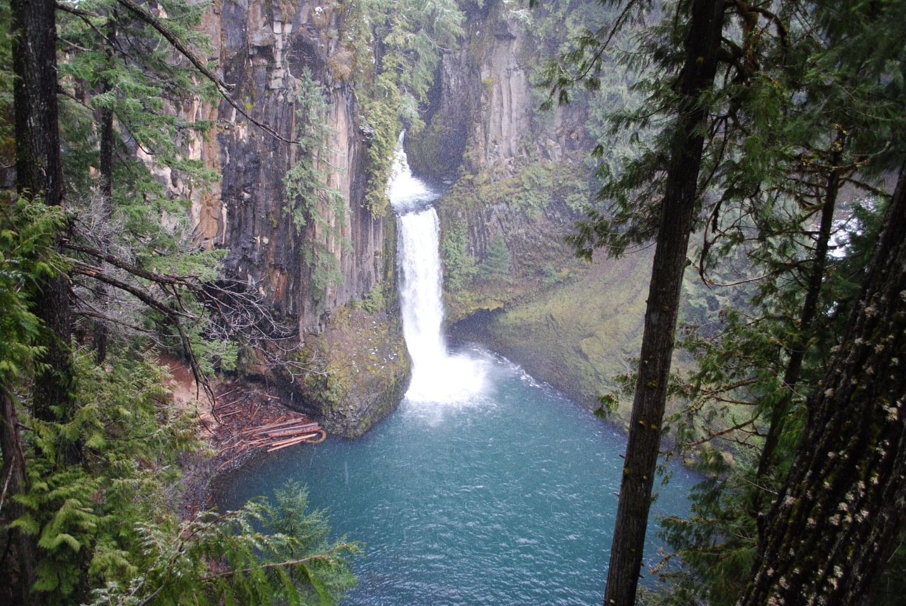

Susan Creek Falls
- 